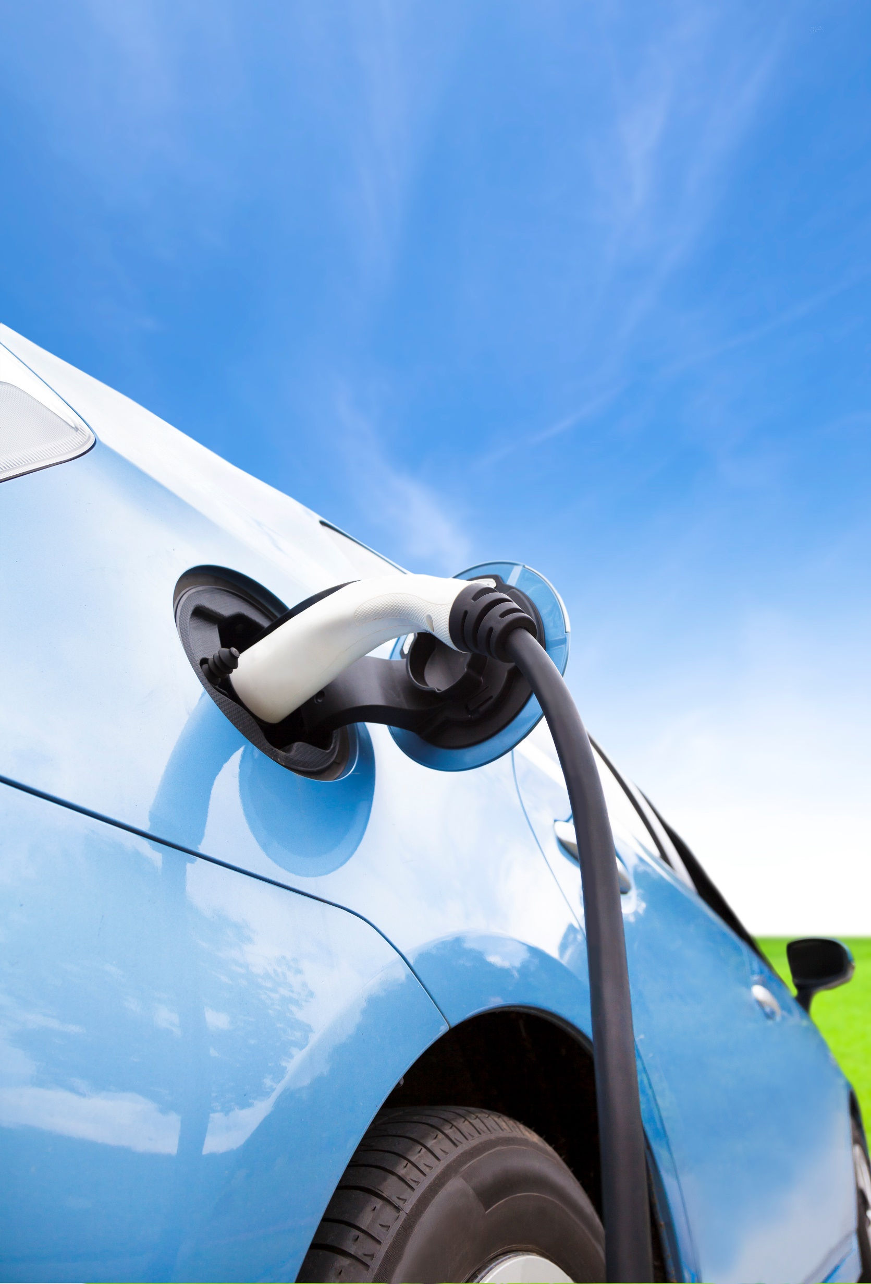

Transport East

Decarbonisation Evidence Base and Strategic Recommendations Report

August 2020

www.transporteast.org.uk

Table of Contents

Glossary 4
1. Executive Summary 5
2. Current Global and UK Decarbonisation Landscape 10
2.1. Global Landscape 10
2.2. UK Landscape 10
2.3. Existing decarbonisation efforts across the UK 14
2.4 The benefits of decarbonisation 15
3. Methods of Reducing Carbon Emissions 16
3.1. Modal Shift Potential 16
3.2 Existing Fuel Technology Options 18
3.3 Lifecycle pathways for alternative fuels 22
3.4 Decarbonisation scenarios 23
4. Transport East Decarbonisation Landscape 26
4.1 Carbon Emissions in the ENSTS Region 26
4.2 Current Regional Activity 28
4.3 Drivers for Decarbonisation 32
4.4 Six initial areas for decarbonisation opportunities 36
4.5 SWOT Analysis of decarbonisation areas 38
5. Indicative long list of regional decarbonisation opportunities 40
6. Transport East Proposed Strategic Actions and Interventions 44
6.1 Key Immediate Actions by Transport East 46
7. Conclusion and Next Steps 49
8. Appendices 50
Appendix 1 – Freight Carbon Emissions of Rail vs Ship vs Road 50
Appendix 2 – Sources and References 51
Appendix 3 – Stakeholders consulted 54

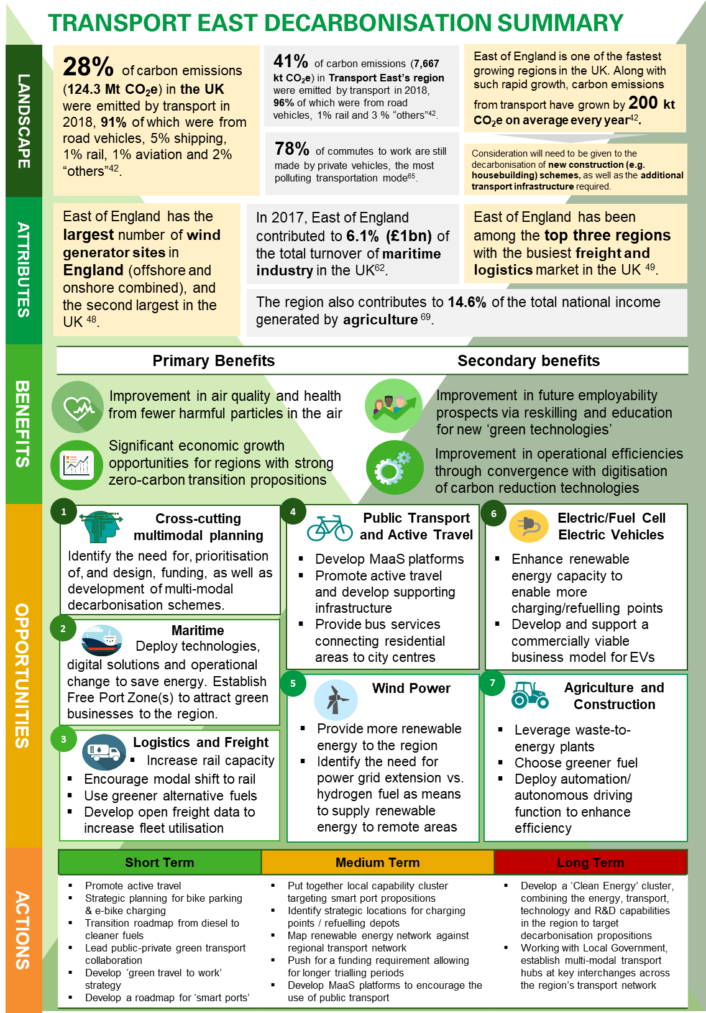

Glossary

Acronyms | Full Form
BEV | Battery Electric Vehicle
CCC | Committee of Climate Change
CDAS | Connected Driver Advisory System
CNG | Compressed Natural Gas
CO₂ | Carbon Dioxide
DfT | Department for Transport
DRT | Demand Responsive Transport
ECML | East Coast Main Line
ENSTS | Essex, Norfolk, Suffolk, Thurrock, and Southend
ESG | Environmental, Social and Governance
EV | Electric Vehicle
FCEV | Fuel-Cell Electric Vehicle
GHG | Greenhouse gases
GPS | Global Positioning System
GVA | Gross Value Added
H₂ | Hydrogen
HFO | Heavy Fuel Oil
HGV | Heavy Goods Vehicle
HyDIME | Hydrogen Diesel Injection in a Marine Environment
ICE | Internal Combustion Engine
IMO | International Maritime Organisation
LCV | Light Commercial Vehicle
LEP | Local Enterprise Partnership
LNG | Liquified Natural Gas
MaaS | Mobility-as-a-Service
MDO | Marine Diesel Oil
MtCO₂e | Metric tonne carbon dioxide equivalent
NGO | Non-government organisations
OEM | Original Equipment Manufacturer
PSV | Public Service Vehicle
R&D | Research and Development
SNTB | Sub-national Transport Body
TDNS | Traction Decarbonisation Network Strategy
ZEM | Zero Emission Mobility

Executive Summary

Current Global and UK Decarbonisation Landscape

The Paris Climate Change Summit in 2015 incited the international community to commit to more active and bolder policies to decarbonise the global economy. In transport, the European Commission has been pushing for full decarbonisation by 2050. Current plans by the commission include schemes to increase modal shift from road to rail, switching to cleaner fuels, and road user charges on polluting vehicles to incentivise the use of greener transport modes. In response to the global climate challenge, a commitment was made by the UK in June 2019 to achieving a net zero carbon economy by 2050 (please refer to page 15 for a more detailed description of the targets set). The transport sector will need to play a significant role in helping to achieve this, given in most regions, it is the single largest contributor to emissions – particularly road transport which currently produces more than 90% of the CO₂ emissions from transport. The UK Government recently published it’s ‘Decarbonising Transport: Setting the Challenge’ report, providing an overarching plan and highlighting key areas to further work on across transport, in order to help achieve net zero targets.

Figure 1.1 – 2018 UK Greenhouse Gas Emissions

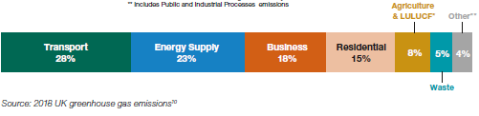
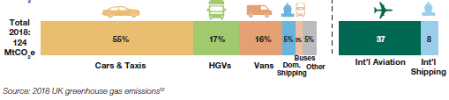

Primary and secondary benefits of achieving decarbonisation

- Primary: A transition to cleaner fuels and more carbon efficient modes of transport will result in improved air quality and health benefits. Cleaner fuels will result in less harmful emissions being released into the air, helping to slow down global warming and reduce the harmful particulates that we breathe in. The increase in green spaces in urban centres, encouraging active travel, will result in improved physical health outcomes across populations. Countries which have made progress in decarbonisation are also arguably better placed to benefit from a transition to a zero-carbon economy in the future.
- Secondary: Greater training and upskilling opportunities (e.g. areas including green fuel technologies) will mean more of the workforce is suitably equipped and ready for the transition to a low-carbon economy. Many decarbonisation initiatives will also likely coincide with the rise of digitisation, resulting in operational efficiencies and further improvements across the transport network. Digital connectivity in itself can act as a driver of benefits of decarbonisation as many of the potential transport related opportunities and initiatives (discussed later in the report e.g. smart ports, MaaS platforms, freight consolidation platforms etc.) will all rely heavily on digital connectivity as an underpinning capability. Complementing this with the broader objective of decarbonisation can also support multiple objectives and policies across industrial strategies, relating to the achievement of sustainable economic growth.

Means of achieving decarbonisation: modal shift and alternative fuel technologies

- Modal shift: There is considerable scope for reducing CO₂ emissions by encouraging both passengers / commuters and businesses (e.g. freight) to adopt less polluting forms of transport. Road transport is currently the most common form of travel to work across the UK, and in aggregate the least environmentally friendly. Investing in connected and integrated public transport networks, and better utilising bus and rail infrastructure could help to improve the situation. Similarly, a large proportion of goods in the UK is currently transported via road; significant reductions in emissions can be achieved from simply transporting more freight via rail as opposed to road.

- Alternative fuel options: Investments in cleaner alternative fuels will become necessary as the hydrocarbons we burn release harmful gases and particulates as well as being environmentally detrimental to extract in the first place. Adoption of the appropriate fuel technology (e.g. battery / hydrogen) across different modes of transport would contribute significantly to reducing carbon emissions. However, it will be important to consider the full life cycle of assets - so as to ensure that the adoption of alternative fuel options does not lead to counterproductive outcomes.

Transport East Decarbonisation Landscape

The largest contributor of carbon dioxide in the region in 2018 was transport (7,667 kt CO₂e/41%), followed by industry and commercial (5,627/30%), domestic (5,040/27%), and agriculture (241.7/2%). By transportation mode, road transport is also the largest contributor of total transport carbon emissions in the region, accounting for more than 90% of GHG emissions ⁴².

However, the region has a number of attributes which could play a part in decarbonising transport. These include: a rich, natural endowment in wind power, a vibrant logistics and freight market, a strong maritime economy, and a largely rural geography with ample green space. These attributes have contributed to the region being one of the fastest growing in the UK, both in terms of population and economy – and there is no reason to suggest that they also cannot contribute to helping reduce carbon emissions whilst simultaneously maximising economic growth.

Drivers for Decarbonisation in the Region

There are a number of drivers (in the form of both challenges and opportunities) which make decarbonisation a significant and immediate focus area, in terms of investment and activity:

Drivers | Trends
Political | A number of political commitments have been made at a national and regional level. The UK Government has set a net zero target of 2050, whilst some local authorities in the region have declared climate emergencies and committed to achieving carbon neutrality by 2030 (note: this target is applicable to the local authorities themselves as opposed to their wider, respective districts / areas). Allocating funding appropriately across initiatives and leveraging public-private partnerships will be needed to help achieve these targets.
Economic | Achieving decarbonisation could see the region establish itself as a national and global hub of best practices with respect to the United Nation’s (UN) Sustainable Development Goals in creating sustainable cities and communities. Potentially declining industries (e.g. the manufacturing sector) could view decarbonisation as a means of rejuvenation, and innovative technology start-ups as an opportunity for them to offer the market new products and services. Collaboration between businesses and local authorities will be needed to stimulate inclusive growth through the adoption of new, sustainable practices and the respective upskilling of workforces.
Social | Greater pressure from different environmental and social activist groups is requiring governments and regional bodies to take concrete actions to tackle climate change. Shifts in expectations and demand from populations are now requiring many businesses to adopt more sustainable and environmentally friendly methods and practices. Engaging with supply chain partners and stakeholders who adopt such practices will be crucial going forward in order to gain the support of the wider population / user base.
Technological | R&D and innovation is (and will continue to be) playing a significant role in identifying new and more efficient carbon reduction technologies and practices. Challenges in generating sufficient ranges for electric vehicles and reducing the cost of hydrogen will undoubtedly require input and contribution from the R&D and innovation sectors.
Legal | The UK Government has set a net zero target of 2050, committing to a number of decarbonising initiatives to achieve this. A current challenge is a lack of legislative progress relating to the trialling and use of alternative fuels. Local stakeholders will need to be aware of the latest standards not only for battery technology but also other forms of alternative fuel with promising future potential.
Environmental | The impact of climate change is having adverse effects on populations, land space and assets / infrastructure across many places. The region is endowed with significant on- and off-shore wind infrastructure and capabilities, providing a more developed opportunity to achieve a green economy through decarbonising transport. Environmental issues resulting from methods of decarbonisation will also need to be considered. For instance, activities involving offshore rare earth and natural gas mining, and palm plantations, are very carbon intensive.

Six initial areas for the region to focus on

There are six initial areas which the region can focus on in order to support the reduction of carbon emissions across transport. These areas have been identified through a combination of research and outputs from stakeholder consultations; and are based on the ability to leverage the strengths unique to the region and the main “pain points” of carbon emissions.

Maritime: The main options to be considered to decarbonise the maritime sector include:  - Technologies that can increase energy efficiency;  - Operational or behavioural change to increase energy efficiency;  - Capture or treatment technology for exhausts;  - Alternative fuels and energy sources | Logistics and Freight: The logistics and freight market represents a significant opportunity to decarbonise transport. This includes:  - Increasing the capacity of the railway network to facilitate modal shift;  - Increasing the use of rail to transport goods;  - Adopting the use of alternative fuels; and  - Using open data to increase fleet utilisation
Renewable (wind) energy: The fact that the region is naturally endowed with strong wind power means that there is a significant opportunity to leverage this as a capability unique to the region. Capitalising on this could see the region establishing itself as a hub for renewable supplies. | Road Passenger Vehicles: There is an opportunity to develop more charging infrastructure and, at the same time, boost road users’ appetite for EV/FCEVs. Greater carbon efficiencies can also be enabled via car-sharing. Employers can co-operate by arranging such schemes for their employees.
Public Transport and Active Travel: There is room to encourage further uptake of public transport and active travel in the East of England. This includes investment in the public transport network to achieve better connection and integration (i.e. in line with MaaS principles). Improved end-to-end journeys for passengers in future are likely to require the interconnection of different forms of transport, which can be utilised to help reduce overall carbon emissions. | Agriculture and Construction: Heavy machinery and equipment used in agriculture and construction can be decarbonised by:  - Switching to cleaner type of fuels;  - Leveraging waste-to-energy plants; and  - Automation to enable more efficient driving behaviour and minimise wastage (e.g. fertiliser, water, etc.)  New construction developments can also better incorporate a ‘spatial’ perspective, ensuring optimal use of land and developments, in ways which minimise the need to travel long distances.

Cooperation amongst regional stakeholders is required to successfully deliver the opportunities / recommendations identified

Efforts from multiple regional stakeholders will be required to successfully deliver any decarbonisation opportunities and recommendations identified. This includes: setting of policy and regulations from central and local government, provision of access to required funding schemes across various central / local government bodies, development of new technologies and solutions by stakeholders in the private sector, extensive research, testing and trialling by those involved in R&D and innovation sectors, and the championing, leading and co-ordinating of activities by Transport East as a Model 1 Sub-National Transport Body (SNTB). The opportunities outlined in this report provide an indicative alignment of necessary actions and interventions to the stakeholders / bodies best placed to deliver them. These will be tested further and agreed with respective stakeholders.

Proposed strategic actions and interventions

The role of Transport East will be crucial in achieving a reduction in carbon emissions across the region’s transport network and ecosystem. In order to achieve a reduction in carbon emissions across transport in the region, Transport East (with the support of stakeholders in the region) could derive value in undertaking the following proposed actions:

Short Term (1 – 3 years):

- Work with employers across the public and private sectors to develop ‘green travel to work’ strategies and policies
- Consider strategic investment in, and placement and positioning of, public transport and active travel infrastructure (e.g. bus stops / stations, cycle lanes, pedestrianised paths, bike parking stations, e-bike charging stations etc.)
- Begin the development of roadmaps specific to the region’s transport industries, for the transition to cleaner and alternative fuels

Medium Term (3 – 5 years):

- Identify locations for, and invest in, greater electric vehicle and fuel-cell electric vehicle charging / refuelling infrastructure (e.g. at stations, depots, ports etc.)
- Facilitate the mapping of the renewable (wind) energy network with the strategic road network, rail network and key economic centres of the region
- Bring together regional capabilities in ‘Smart Port’ technologies and develop a cluster / working group to position the region as a hub for maritime innovation

Long term (5+ years)

- Develop a clean energy cluster, combining the skills and capabilities of the region’s energy, transport, technology and R&D sectors
- Work with local government to develop multi-modal hubs at key interchanges across the region’s transport network

A more comprehensive evaluation of potential actions and initiatives to undertake is included in Section 6.

Current Global and UK Decarbonisation Landscape

2.1. Global Landscape

The Paris Climate Change Summit in 2015 incited the international community to commit to more active and bolder policies to decarbonise the global economy. In transport, the European Commission has been pushing for full decarbonisation by 2050. The plan includes schemes to increase modal shift from road to rail, switching to cleaner fuels, and road use charges on polluting vehicles to incentivise the use of greener transport modes.

The ‘Decarbonising Transport Initiative’ is another international movement that focuses on policy development and progress tracking through scientific studies. The Decarbonising Transport Initiative does not advocate specific measures or policies; however, building on an evidence-based assessment of mitigation impacts, it identifies options for decision-makers to achieve their targets – for instance the Nationally Determined Contributions (NDCs) submitted by countries under the Paris Agreement, as well as targets set by sectors, companies and cities. The initiative builds on contributions from the following governments: France, Korea, Ireland, the Netherlands and also the European Commission, as well as other prominent international organisations such as the World Bank.

Figure 2.1 below shows how CO₂ emissions globally have been increasing, though at a decreasing rate, since 2000¹:

2.2. UK Landscape

In response to the global climate challenge, a commitment was made by the UK Government in June 2019 to achieving a net zero carbon economy by 2050. In practice, what this means for UK transport is the urgent need to bring down the current emissions (latest data available in 2018) from 124.4 MtCO₂e (112.9 associated with road and 123 take the form of CO₂) to emissions to 33 MtCO₂e (2 associated with road) with the assumption that the remainder is offset by other forms of carbon-reducing measures, e.g. re-forestation and carbon-capture technology, among others². This does not however take into account emissions from the international travel of goods and people and is primarily focused on internal measures.

Comparing Figure 2.1 and 2.2, the UK’s decarbonisation performance has been comparatively better than other countries. Whilst global emissions have been increasing, albeit at a slower rate since 2005, the UK’s greenhouse gas emissions have been in consistent decline since 2000.

Notwithstanding the ongoing reduction in emissions, if the UK is to meet it’s 2050 net zero carbon ambition, further work is required to decarbonise the UK economy. This includes establishing means to track carbon emissions from cross-border air and sea travel, and logistics, and reducing these too where possible.

A short-term measure being adopted in many cities is the application of financial penalties to drivers / operators of highly polluting vehicles. In the wake of travel restrictions from Covid-19, many cities are also considering (or have begun) re-allocating road space to pedestrians and cyclists. Initiatives are also underway to deploy electric vehicle charge-points, encourage adoption of zero emission vehicles, decarbonise rail traction, construct freight consolidation centres, and improve the accessibility and attractiveness of mass public transport.

Two principal fuels are considered to be the most feasible and clean alternatives: electrification (battery), and hydrogen fuel cells. Compressed Natural Gas (CNG) is being considered as a stop-gap measure but is not a zero–emission fuel.

The UK Government has published multiple strategies to inform and support its net zero objective, including: the ‘Road to Zero’, which targets ending the sale of new conventional petrol and diesel cars by 2035, and the Transport Decarbonisation Plan.

UK Transport Decarbonisation Plan

To support the UK Government’s commitment to achieve net-zero carbon by 2050, the Department for Transport (DfT) has released the “Decarbonising Transport: Setting the Challenge” report, which provides an overarching strategy to help enable the UK to achieve it’s 2050 net-zero emissions target. The report outlines DfT’s six strategic priorities to deliver the vision of a net zero transport system³:

- Accelerating a modal shift to public and active transport: The government will encourage both public and active transport as the first choice for travel. With the adoption of new transport models, such as Mobility as a Service (MaaS), the government will also support and facilitate the development of new technologies and encourage people to use these new platforms.
- Decarbonisation of road vehicles: The report notes that there needs to be a significant shift in the types of vehicles used (e.g. fuel technology options), and the way road users drive. To ensure a successful transition to zero emission road transport in the UK there will need to be: a strong regulatory framework, willingness from the user base to adopt new solutions, the right market conditions, adequate (electric) vehicle supply, and investment in and development of charging infrastructure. There are significant economic opportunities for those who can provide solutions to these challenges, but there will need to be investment across the board in low-carbon supply chains to enable such opportunities to be exploited.
- Decarbonising the transportation of goods: Changes in consumer behaviours need to be considered when evaluating the future demand for transporting goods. With the increase of ‘next (and even same) day delivery’, more companies will have to innovate their last mile logistics deliveries to ensure they are able to compete. With this comes huge opportunities for innovative new digital solutions and data sharing platforms which can in turn also reduce the negative impact of congestion and thus reduce carbon emissions.
- Place based solutions: As emissions are not produced consistently across the country, a more tailored and localised approach is needed for an effective and efficient overall reduction. A true understanding of how, where and why specific locations produce more emissions must be built to allow for the most effective response. The UK Government is seeking to work with a range of stakeholders, including Local Authorities, mayoral Combined Authorities, Sub National Transport Bodies (SNTBs), and other interested parties, to obtain the insights required for effective place-based solutions.
- UK as a hub for green transport technology and innovation: Government intends to make the UK a world leader in green transport technology by exploiting our strong and extant research and development (R&D) capabilities, and exploring how greater collaboration can be stimulated between R&D organisations and industry.
- Reducing carbon in a global economy: The UK wants to feed developments and best practices into the wider global economy, citing that reducing emissions from transport is a global, not only UK, priority. Impacting international travel of goods and people for instance will need collaboration between and across multiple countries if global targets are to be achieved.

The Department for Transport (DfT) has stated its forward intentions to:

- Take a holistic view of transport, looking at challenging new cross-modal approaches to mobility whilst maximising the potential in each mode to deliver the UK’s carbon reduction targets; and
- Continue building on decarbonisation policies by working with industry and business groups, academic and research institutions, community and interest groups, environmental NGOs, local authorities, and the public, to focus on the six strategic priorities listed above.

Existing decarbonisation efforts across the UK

Decarbonisation efforts have always been at the core of government investment in future infrastructure for transport, even prior to its policy commitment. Most efforts have been focused on road transport since it is the biggest domestic contributor to carbon emissions in the country. Existing efforts across road, rail, aviation and maritime, can be categorised as follows:
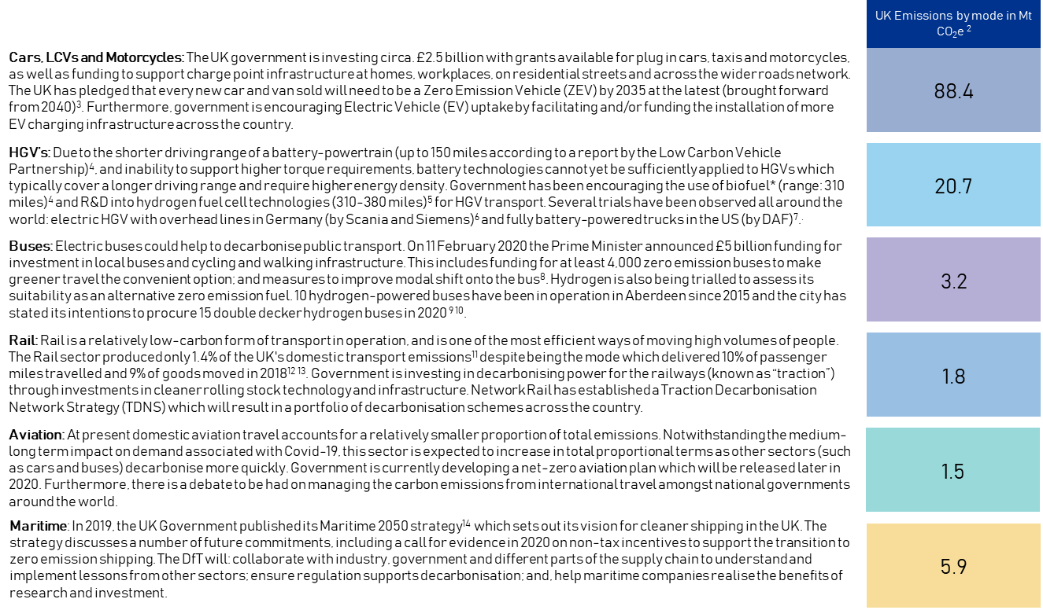
*It is noteworthy that even though biofuel is cleaner than conventional fossil fuels, it is still a variant of hydrocarbon and therefore still emits carbon when burnt. Furthermore, if biomethane is leaked prior to combustion, the methane released into the atmosphere will have a larger potency of trapping heat than carbon dioxide. Methane contributes to global warming more significantly in terms of GHG potency than carbon dioxide. However, methane has a much shorter lifespan (8-12 years) than carbon dioxide (>100 years).

2.4 The benefits of decarbonisation

There are a wide range of primary and secondary benefits associated with a reduction in carbon emissions:

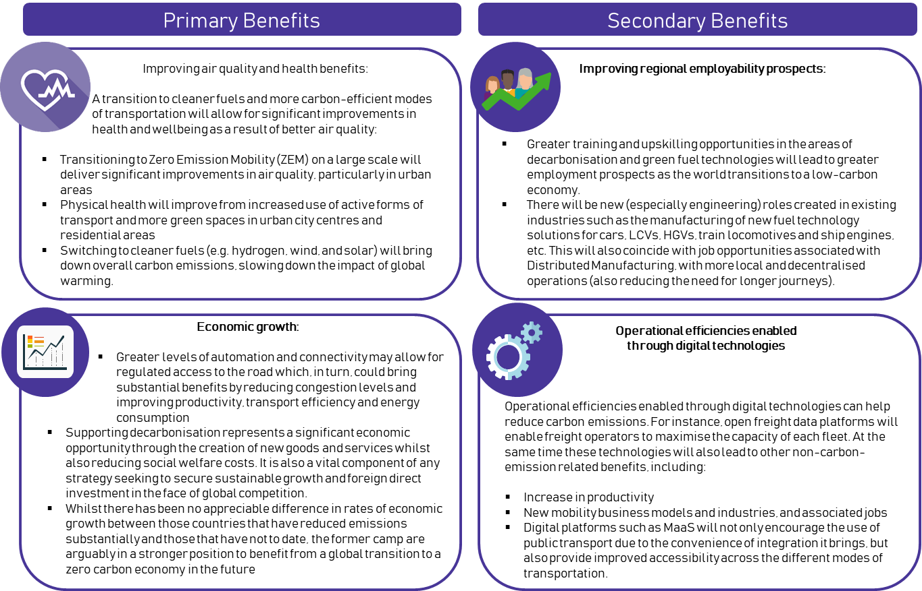

Methods of Reducing Carbon Emissions

3.1. Modal Shift Potential

Using road transport (primarily individual car use) is still the most common method to travel to work. Increasing uptake of other modes of transport will help curb carbon emissions per capita from transport. Given the reliance on cars as the main method for travelling to work, a modal shift to other transport modes will contribute significantly to reducing carbon emissions.

Figure 3.1.1: Carbon emissions and percentage of journeys to work made by various transport modes in the UK¹⁵ ¹⁶
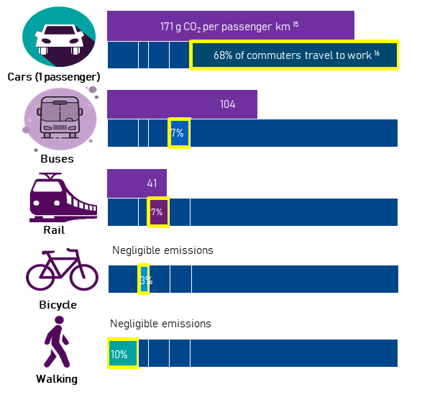
Similar to the movement of passengers, the majority of freight is still being transported via road. A crucial part of decarbonising freight in the region will involve shifting from road (HGVs, trucks, vans etc.) to rail. However, the existing rail network is already running at near capacity and improvements in infrastructure are needed to be able to accommodate greater freight capacity on the network. This includes greater electrification of tracks on certain routes and greater allocation of track space and slots on timetables for freight operators.

“Until public transport infrastructure is improved, and the region is better connected, there are few incentives for people to stop driving.” – Stakeholder interview quote

Figure 3.1.2: Carbon emissions and percentage of goods moved by various transport modes in the UK (See Appendix 1 for Further Sources and Details)

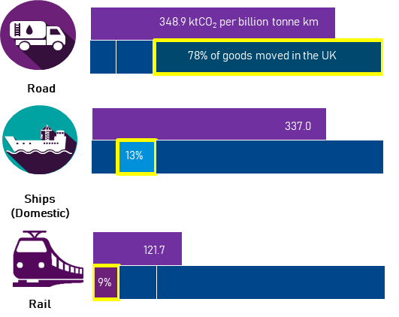

“There is a need to shift more freight to rail but the rail network is already operating at near capacity level.” – Stakeholder interview quote

“Rail is currently not very competitive over shorter distances for distributing freight. As a result, all journeys for freight from the port that are delivering to the region, are by road.” – Stakeholder interview quote

“There is a lack of initiatives around developing the rail track capacity to enable more goods to be delivered by rail.” – Stakeholder interview quote

In order to best encourage a modal shift of transport modes for both passengers and freight, the services and infrastructure developed will need to be accessible, trustworthy and reliable. Passengers, consumers and businesses will need to feel that they are benefitting from the use of these services, in order to generate high adoption rates. For instance, public transport networks must be well connected and integrated, in such a way where it is easy for passengers to use for everyday travelling purposes. A region that can build its transport network in this way, increases its chances of incentivising its population / user base to maximise use of these services.

3.2 Existing Fuel Technology Options

Direct plug-in / electrification

The deployment of Battery Electric Vehicles (BEVs) is currently at the forefront of methods being used to electrify road vehicles. BEVs are among the most mature technology solutions among zero-emission vehicles, with a number of OEMs having invested heavily in this technology. Plans announced by OEMs in 2019 suggest that circa. USD 300 billion will be invested in EVs, almost half of which will be targeted at the Chinese market¹⁷. There are also significant R&D activities being carried out to extend the driving range of battery powertrains and apply recent advances in battery technology to wider transport sectors such as aviation, shipping and rail ¹⁸. Electrification of rail is principally achieved by providing overhead catenaries to accommodate rolling stock with electric engines. Electrification can also be achieved by installing third rail, but this is largely limited to the South East of England. Batteries are most likely going to be introduced in the future as a secondary energy source to cover patches of tracks in between routes which have not yet been electrified (i.e. gaps in provision of overhead line electrification).

Current uptake / application in the UK or globally
Cars and LCVs
As at 2019 Q3, of the 37.2 million cars and LCVs registered in the UK, 230,800 were plug-in electric or hybrid vehicles. However, the UK government has been making significant investment in charging infrastructure for EVs¹⁹ ²⁰. As at 2019 Q3, 15,116 public charging devices were available in the UK (312% increase since 2015). Of these, 2,495 were rapid charging devices²¹.

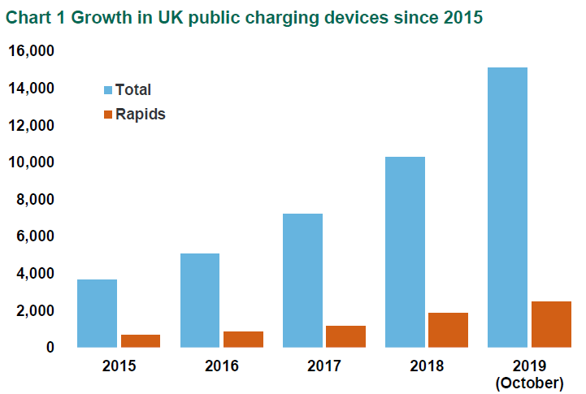

Buses
As of 2018, approximately 700 of the 35,000 buses in England were electric, most of which are in London²². The UK Government aims to have all UK buses fully electric by 2025 and has allocated £170m in the recent budget to improve bus services and make them greener as well as more reliable. This includes £50 million to help create the first fully electric bus town²³. Local authorities can apply to become the UK’s first all-electric bus town, setting best practice in environmentally friendly public transport. The winning areas will receive up to £50 million to help pay for a brand-new fleet of electric buses.

The government is also trying to increase uptake of buses in areas not covered by bus operators through a new £20 million fund to encourage the development and trialling of on-demand ride sharing services.

A further £30 million of funding is also available from 2020 to 2021 to help local authorities outside London to help improve current bus services or restore those which have been lost.

Rail
At present, around 40% of the UK rail network is electrified - much less than comparable European countries which are typically 60% or more electrified²⁴.

With the UK government pledging to fully decarbonise the rail network by 2040, there is significant scope for the implementation of new technologies. The East Coast Main Line (ECML) proved that the UK could deliver rail electrification efficiently, with 2,250 single-track kilometres electrified for £671 million (adjusted for 2018). The programme took seven years from authorisation to completion.

At present, battery technology is still in its early phases with application to rail. In 2019 Bombardier signed a £89 million deal to make the UK’s first lithium battery powered trains²⁵. Dual electric-battery trains can be potentially applied to a rail network which is partially electrified. The energy stored in the batteries can help such trains to cover and run through patches of the network which are yet to be electrified.

“Some areas of the rail network will likely not be electrified until 2050-2060. Where this is the case, electric and hydrogen trains could provide an interim solution.” – Stakeholder interview quote

Hydrogen fuel

Hydrogen provides the ability to travel further on a single “charge” than battery electric vehicles due to higher energy density. It also benefits from quicker speed of (re)fuelling – similar to current petrol- and diesel-powered vehicles - making the technology more suitable for use in longer distances and more energy intensive use cases, usually covered by public service vehicles (PSV), HGVs and trains. It is also possible to produce “green hydrogen” fuel through the use of electrolysis, powered from renewable energy sources. At present, however, hydrogen has a significant cost premium, with powertrains largely still in the R&D phase, and very limited production, distribution and storage facilities. There are varying levels of investment in this technology globally with nineteen governments around the world currently having “hydrogen strategies” to develop hydrogen fuel cell technologies within their borders.

Current uptake / application in the UK or globally
Cars and LCVs
The current market for hydrogen fuel cell electric vehicles (FCEVs) is still relatively small but has significant potential. Globally, in 2019 there were 7,500 hydrogen fuel cell cars sold (90% up on 2018)²⁶. Leading countries in FCEVs by uptake as of 2018 include: Japan (2,800 units in operation)²⁷, South Korea (2,000)²⁸, and China (1,200)²⁹.

As described above, the cost of R&D in hydrogen is relatively much higher than that of batteries, which is why few OEMs have attempted to tap into the market potential. However, OEMs in (and governments of) several countries in East Asia such as China, Japan, and South Korea recognise the advantages of hydrogen over batteries, including its longer driving range and ability to be distributed beyond the reach of the electricity grid network. This is demonstrated through the relatively higher uptake of FCEVs in these countries.

Buses
The UK leads the world in the application of hydrogen in buses, with Aberdeen being the first city in the world to operate 10 buses (manufactured by Van Hool) running entirely on green hydrogen in 2015. The city is procuring a further batch of 15 double-decker hydrogen buses (manufactured by Wrightbus) in 2020 ³⁰ ³¹. The hydrogen bus project in Aberdeen received significant support from the government, the EU (Fuel Cells and Hydrogen Joint Undertaking) and partnerships with private company suppliers. The project also includes Aberdeen’s own hydrogen fuel manufacturing facility. In addition, TfL announced that it has invested £12 million in 2019 in new hydrogen buses and refuelling infrastructure which it anticipates being delivered in 2020³².

HGVs
While current numbers are low (the UK currently does not have any hydrogen powered HGVs), ‘Hydrogen Roadmap Europe’ has predicted that there will be 45,000 fuel cell trucks and buses on roads by 2030 in Europe³³.

Internationally, the biggest investor in renewable energy trucks is China. In 2019, the Chinese truck manufacturer Beiqi Foton Motor announced its ambitious new plan to manufacture 200,000 new energy trucks by 2025.
Rail
Network Rail is currently preparing a cross-industry Traction Decarbonisation Network Strategy (TDNS). This strategy will set out the case for, and plan to achieve the replacement of all diesel-powered rolling stock by 2050 with trains powered by electricity, batteries, or hydrogen fuel cells. It will provide information and analysis to inform Government’s decisions on how to decarbonise traction power on different parts of the national rail network.
It will aim to prioritise the conversion of currently unelectrified routes by evaluating the most appropriate traction type for each line and will be carried out in a way which considers the carbon opportunity costs of traction conversion within a more traditional cost/benefit analysis.
For hydrogen specifically, it will consider how hydrogen trains might be most effectively deployed, especially in areas where there is limited access to a power network. The TDNS programme will be set out in 2021³⁴. The first trial of hydrogen trains, HydroFLEX, began in the West Midlands in 2019³⁵ and East Midlands Railway plans to trial hydrogen trains in the next 2-3 years³⁶. Furthermore, Scotland is converting an old train unit to hydrogen as part of its trial.

Marine
HyDIME (Hydrogen Diesel Injection in a Marine Environment) is a 12 month, Innovate UK funded project that will use an environmentally friendly form of hydrogen as a fuel for a commercial ferry operating between Shapinsay and Kirkwall in Orkney. HyDIME aims to make waves in the marine industry by proving the safe integration and use of hydrogen on vessels.

One of HyDIME’s goals is the design and physical integration of a hydrogen injection system on a commercial passenger and vehicle ferry which will be the first of its kind worldwide³⁷.

Biomethane and Natural Gas

Alternative fuels such as Biomethane / Compressed Natural Gas (CNG) provide an opportunity for a short-to-medium term solution for decarbonisation, albeit with some limitations.

Together with reducing carbon emissions by up to 85%, biomethane provides a saving of 30-35% compared with comparative journeys on diesel fuel. However, a key concern is the impact of Biomethane on Ozone, which – if leaked – is 25x more potent in trapping heat than CO₂. In 2018 the total GHG emission savings achieved by displacing fossil fuels with low carbon fuels has been estimated at 3.7MtCO₂e. This is equivalent to taking over 1.7 million cars off roads.

Current uptake / application in the UK or globally
HGVs
The principal biofuel in the UK is Compressed Natural Gas (CNG), with CNG Fuels the principal supplier. Several retailers and logistics delivery companies such as John Lewis, Asda, Argos and Hermes are switching their fleets to CNG-based trucks. John Lewis, for example, will begin using renewable biomethane made from livestock manure to fuel almost 300 of its delivery vans³⁸. However, public coverage of refuelling infrastructure in the UK is relatively limited. There are three currently operational CNG fuelling stations operated by CNG Fuels in Northampton, Crewe and Leyland. A further 11 stations are either being constructed or planned across the country³⁹.

Marine
In January 2020, the International Maritime Organisation (IMO) banned ships with exhaust emissions that contain more than 0.5% of sulphur content, forcing ship-makers to move towards Liquefied Natural Gas (LNG). Furthermore, the European Union requires each member state to have at least one LNG bunkering port, and proposed legislation may see ships mandated to use shore power whilst berthed. In practice, however, the majority of ships and boats are still powered by Marine Diesel Oil/Heavy Fuel Oil (MDO/HFO). To date, less than 1% of the total marine fleet globally is powered using LNG, with most vessels operating in the North Sea/Baltic Sea region and concentrated in Norway⁴⁰.

3.3 Lifecycle pathways for alternative fuels

While there is a wide range of alternative fuels, each tailored for a very specific use and possessing varied decarbonisation potential, the decision to invest in new infrastructure to enable the use of cleaner fuels should be considered with full lifecycle pathways in mind. Outlined below is an example lifecycle mapping of the different fuel types explained in the preceding pages. This highlights potential pathways for different fuel / vehicle types and helps to indicate initial areas which may require investment / policy changes from public and private sector stakeholders.
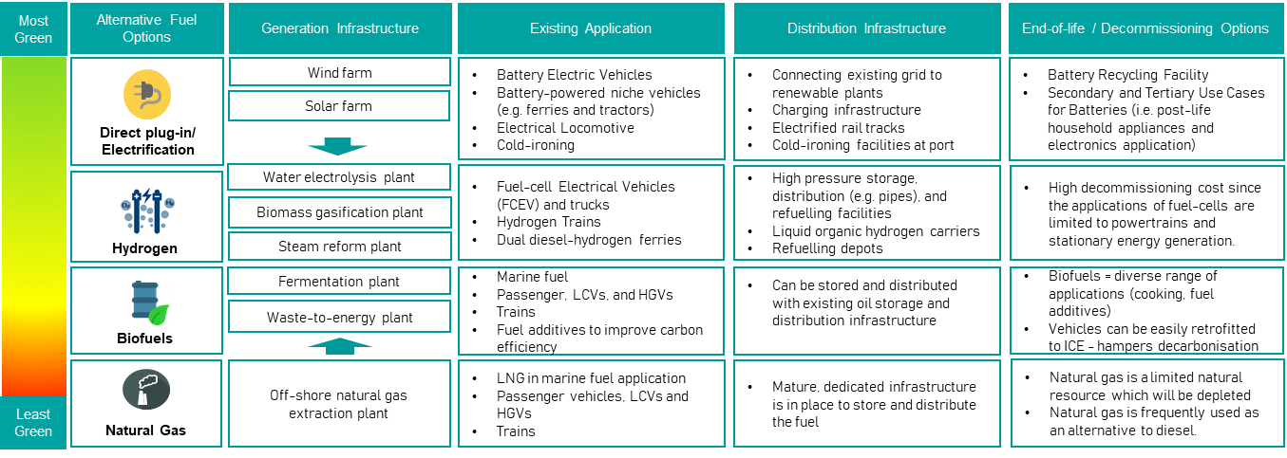
Environmental
Socially Responsible
Good Governance
The environmental pillar focuses on the decarbonisation potential for each infrastructure option to meet the UK’s policy objective to be net zero carbon by 2050. As it currently stands, cleaner fuels are less mature and more expensive to adopt.
The social pillar refers to the need for an aligned position on decarbonisation efforts amongst stakeholders such as local authorities, employers, workers, and local residents so as to ensure that everyone benefits from the investment.
This pillar requires the management of an organisation to take an action that ensures commercial viability but also puts sustainability at the core of decision-making. This includes transparency and established methods to manage risks.

3.4 Decarbonisation scenarios

Depending on the extent of success in implementing decarbonisation interventions, there are a total of four scenarios up to 2050 that the UK Committee for Climate Change (CCC) has developed since 2016. These are:

- Net Zero: this scenario represents the interventions that need to be accomplished by 2050 in order to meet the Net Zero policy target
- Max: this scenario was developed in 2016 when the target by 2050 was to keep the total UK emissions around 160 MtCO₂e/year or less. It represents higher deployment towards the maximum limits that are likely to be feasible, acceptable and sustainable. This scenario is less ambitious than the “Net Zero” scenario
- Central: this scenario represents UK CCC’s best assessment of the technologies and behaviours required to meet targets cost-effectively while meeting other criteria in the Climate Change Act. This scenario is less ambitious than the “Max” scenario
- Barriers: this scenario represents less favourable conditions for key measures (technological barriers, failure to achieve cost reductions, or market barriers)

For each scenario, the forecasted annual carbon emissions and extent of interventions required are outlined in the table below:

Table 3.1: Decarbonisation scenarios by 2050

Scenarios | Net Zero* | Max** | Central** | Barriers**
Surface transport | With the assumption of full electricity decarbonisation:  - 100% of cars and vans are electric vehicles  - 100% of buses are low carbon (half H₂, half EV)  - HGVs are harder to decarbonise. New research by CCC suggests that it is possible to get to very-low emissions by 2050 by switching most of these vehicles to hydrogen power or electrification.  2 MtCO₂e | With the following assumptions:  - 100% of cars and vans are EVs  - 95% of buses are low carbon (half H₂, half EV)  - 50% of HGVs use H₂ and 40% EVs  5 MtCO₂e | With the following assumptions:  - 93% of cars and vans are EVs  - 95% of buses are low carbon (half H₂, half EV)  - 40% of HGVs use H₂ and 25% EVs  19 MtCO₂e | With the following assumptions:  - 70% of cars and vans are EVs  - 90% of buses are low carbon (half H₂, half EV)  - 20% of HGVs use H₂ and 25% EVs  42 MtCO₂e
Aviation and shipping | Aviation: some use of hybrid-electric aircraft from the 2040s, and from reductions in design speeds of aircraft  Shipping: improved energy efficiency and ship operations, and use of alternative fuels  32 MtCO₂e | Aviation: emissions 15% lower than 2005 levels  Shipping: full take-up of technological and operational measures; further increases in ship size and use – still limited use of biofuels and LNG  40 MtCO₂e | Aviation: emissions at around 2005 levels  Shipping: speed reductions and increases in the average size of unitised container ships; limited use of biofuels and LNG  46 MtCO₂e | Aviation: emissions not capped, increasing to 40% above 2005 levels  Shipping: improvements reflecting IMO’s Energy Efficiency Design Index but limited further abatement  63 MtCO₂e
* Information taken from CCC Report: Net Zero The UK’s contribution to stopping global warming – May 2019 (Source)
** Information taken from CCC Report: UK climate action following the Paris Agreement – October 2016 (Source)

Furthermore, a forecast published by the DfT also suggests that the net zero target cannot be achieved in the transport sector without introducing major interventions (Information taken from DfT via Transport Network).

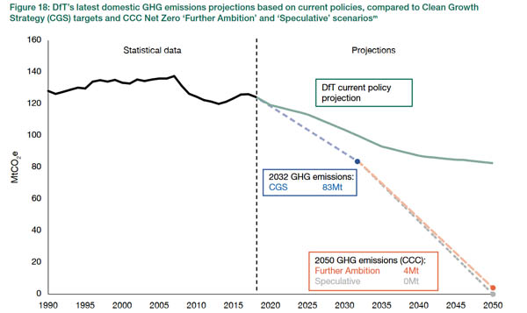

Transport East Decarbonisation Landscape

Important Note: The analysis contained within the following section (and across other parts of this report) is based on the best possible (and available) information and data as at the reporting date.

Within this section, the majority of the analysis conducted on carbon emissions is primarily focused on the regions covered under the remit of Transport East, which are: Essex, Norfolk, Suffolk, Thurrock, and Southend-on-Sea (ENSTS). To highlight instances where data and analysis is focused primarily on these regions, we have referenced accordingly using the acronym ‘ENSTS’.

There are some instances where datasets on each specific region / local authority are not currently available (mainly relating to the wider decarbonisation landscape and contextual information e.g. regional assets). The available information within these instances is more generic and encompasses the wider East of England region comprising Peterborough, Cambridgeshire, Luton, Essex, Norfolk, Suffolk, Thurrock and Southend-on-Sea. This is also highlighted and referenced where appropriate.

4.1 Carbon Emissions in the ENSTS Region

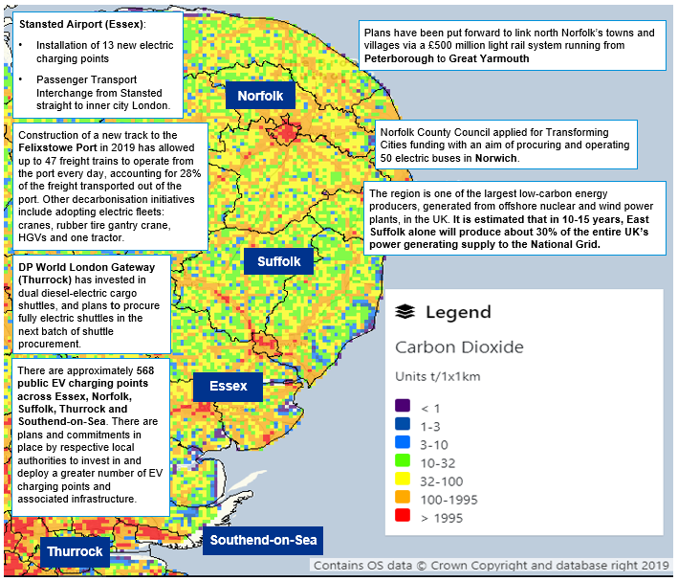
Sources: BEIS – National Atmospheric Emissions Inventory (Carbon dioxide emissions), DfT Statistics: Electric vehicle charging devices by local authority, Letter from Suffolk County Council to BEIS and DHLCG (Dated 11 May 2018)
Note on nuclear: Although this provides potential for the generation of low-carbon energy, considerations will need to be made in respect of other potential environmental impacts.
The largest contributor of carbon dioxide in the region in 2018 was transport (7,667 kt CO₂e/41%), followed by industry and commercial (5,627/30%), domestic (5,040/27%), and agriculture (241.7/2%). Meanwhile, transport in ENSTS makes up approximately 5% of the total transport carbon emissions across the UK ⁴². The emissions from agriculture in the form of methane is likely to be more significant which means that the impact of emissions from agriculture is potentially more significant than anticipated / outlined. With reference to the heat map, emissions are concentrated in city centres such as Norwich, Ipswich, and Bury St. Edmunds. The amber, web-like strokes spreading out of Norwich on the map also highlights the significant contribution of transport / the strategic road network to CO₂ emissions in the region.

With reference to Figure 4.1 below, carbon emissions from transport in Essex, Norfolk, Suffolk, Southend-on-Sea and Thurrock have seen a steady increase since 2010.

Several local authorities in the region, including East Suffolk, Mid Suffolk, North Norfolk, and Suffolk, have declared a climate emergency in response, and have committed to being carbon neutral by 2030 (note: this target is applicable to the local authorities themselves as opposed to their wider, respective districts / areas)⁴³. Local government bodies across the region need to make a conscious effort and actively engage with industry to identify and implement measures to support transport decarbonisation to meet local and national policy commitments.

By transportation mode, road transport is the largest contributor, which accounts for 96% of the total transport carbon emission in Essex, Norfolk, Suffolk, Thurrock & Southend (ENSTS), as shown by figure 4.2 below. “Rail” and “Other” account for 1% and 3% respectively. This provides a strong indication for the prioritisation of decarbonisation efforts. With rail being a greener transportation mode in operation, opportunities may exist to utilise rail more in meeting the demand for transport of passengers and goods in the region.

Further information relating to the decarbonisation landscape in the context of each transportation mode in ENSTS can be found on pages 33 – 34.

The region is one of the fastest growing regions in the UK, both in terms of population and economic growth. Much of the region benefits from its proximity to London and is increasingly linked with London and the South East in terms of labour and housing markets. The region is also the fourth largest exporting region in the UK after London, the South East and the West Midlands. The regional economy is heavily reliant on services, with a strong financial services sector but is also active in manufacturing (e.g. automotive, pharmaceuticals) and ICT⁴⁴.

4.2 Current Regional Activity

Overview of current decarbonisation plans in the region

The UK's average per capita emissions nationally fell from 8.7 tonnes/ person in 2005 to 5.4 tonnes/ person in 2018⁴⁵. Over the same period per capita emissions in ENSTS demonstrated a similar downward trend, with a below-UK average 8.5 tonnes in 2005 to 5.0 tonnes in 2018. The downward trend suggests that energy consumption per capita in the region has improved significantly since 2005⁴². However, if the 2050 net zero target is to be achieved, more needs to be done to decarbonise road transport in the region.

There has been progress made to date over the past few years, with a number of initiatives considering the need, and options, for decarbonisation in the region. Examples include: the Climate Change Adaption and Carbon Reduction Scoping Report (produced by the University of East Anglia and New Anglia LEP in July 2019), the Norfolk and Suffolk Local Industrial Strategy, which states the vision for Norfolk and Suffolk to be ‘the UK’s clean growth region’ (published by New Anglia LEP in January 2020), the South East LEP Local Energy Strategy and Clean Growth Working Group, and the planned establishment of a Clean Growth Taskforce with the aim to “embed clean growth in the development and delivery of actions and decisions which deliver the Economic Strategy and Local Industrial Strategy” ⁴⁶.

Multiple efforts across the region have been made to identify specific actions for the transport sector which include; embedding clean growth ambitions in transport strategies and policies to ensure that clean growth is considered in decision making with respect to transport; reducing the need for transport through an increase in flexible working and digital connectivity; improving access to, and use of sustainable modes of transport through behavioural change; working with the Connected Places Catapult (CPC) and Highways England to drive transport innovation and support for SMEs; development of an EV strategy focusing on infrastructure improvement as well as increasing take up rates of EVs; considering various types of modes and alternative for freight and air travel; initiatives to improve air quality across the region; and increasing the resilience of infrastructure.

East of England key regional attributes

In addition to the initiatives above, the region also has several key attributes that position it well for achieving a reduction in carbon emissions. These include:

Green Energy Generation
A key strength of the region relates to its energy production capabilities, both current and future. Offshore, the area hosts over 100 gas fields, over 150 gas-related platforms and 4,500 km of pipelines⁴⁷. The Bacton gas terminal and network of offshore gas platforms supply over a third of the UK’s low carbon transitionary fuels. The bioenergy industry is worth nearly £2bn and is based on the scale of agriculture locally, with 13.7% of England’s crop output and 9% of the livestock output. The region is also amongst the leading producers of clean energy onshore, largely generated by wind and nuclear. The East of England has the second largest number of onshore wind generator sites nationwide (879), with only Scotland having more (3,468)⁴⁸. The region also has the highest concentration of offshore wind energy generation as of 2018 in the UK.

Logistics and Freight Market
The East of England has one of the strongest logistics, freight and distribution markets nationwide. The region has been among the top 3 UK regions which have ‘lifted’ the most amount of goods in million tonnes of overall haulage since 2017⁴⁹.

The region is a base for a number of large freight cargo companies including Freightliner, GB Railfreight and DB Cargo. These companies have been in discussions with Network Rail and the DfT with respect to improvements required in the rail links across the region to allow more trains to run and reduce lorries travelling on the A14⁵⁰.

HGVs still make up the larger proportion of the freight market share in East of England, with 65-75% of goods coming through the Felixstowe and London Gateway ports being moved via road⁵¹.

Maritime Economy
The East of England is home to several of the busiest ports in the UK, including Felixstowe, London Gateway, Lowestoft, King’s Lynn, and Ipswich Dock. With its active and vibrant port activities, the region is well-positioned to spearhead initiatives for decarbonising shipping and the wider maritime economy.

Currently 25% and 35% of the goods going through Felixstowe and London Gateway respectively are moved by rail. In 2019, a new track pathway to Felixstowe has allowed up to 47 freight trains a day to operate from the port to Ipswich⁵⁰. However, the existing rail network has already been operating at near full capacity and further upgrades are needed to allow rail to play a more significant role in meeting decarbonisation goals.

Clean Energy Cluster
There is currently a large energy sector in the region and also extensive R&D capabilities (e.g. within University of East Anglia and University of Cambridge). There could therefore be an opportunity to develop a ‘clean energy cluster’, combining practical expertise of energy, transport and technology sectors, with R&D expertise of universities and others.

Decarbonisation Initiatives in ENSTS

There are already a number of existing initiatives and efforts underway across multiple transport modes, aimed at reducing carbon emissions. These include:

Cars
In the Transport East region only 13% of households do not have access to a car, compared to 26% across the whole of England. From 2018 - 2019 an additional 1,522 plug-in EV cars and vans were registered in the Transport East region with the overall fleet of 5,241 vehicles representing 29.2% of the total in England at that time⁵².

There have been a number of charging infrastructure initiatives launched in the region including the installation of 40 charging points around North Norfolk in 2019 as part of a £250,000 initiative.
There is also a presence of local businesses such as Lotus which manufactured the first British all-electric hyper car (Lotus Evija) in Hethel, Norfolk, marking the start of c.£100m of investment for R&D and manufacturing ⁵³. The company has also committed to becoming an all-electric car manufacturer from June 2020.

HGVs
The A14 to Felixstowe is a congested route that connects with the A12 at the Copdock Interchange to the south of Ipswich and provides connectivity to the M25 and London from Felixstowe port. This route accounts for approximately 70% of the road freight out of Felixstowe port. The A12 / A14 Copdock Interchange is a pinch point on the Strategic Road Network (SRN), with significant delays and queueing observed in peak hours on the A12 northbound approach. Trafficmaster GPS data shows that average peak hour journey times are more than 50% slower than the overnight ‘free flow’ conditions. Highways England has not to date announced or committed to improvement schemes for this junction⁵².

The region also hosts local businesses such as Tevva, a business specialising in the development of electric delivery vehicles with a focus on battery system development, telematics, power electronics, and software development ⁵⁴.

Bus
The region has a lower than average journey to work bus mode share (4% as compared to an average of 7% for England as a whole). This is reflective of the region’s rural geography and difficulties in providing public transport services in rural areas⁵².

- Norfolk County Council has applied for £18 million from the government’s ‘Transforming Cities’ funding pot with the aim of funding for 50 new electric buses in Norwich ⁵⁵.
- Norfolk-based Equipmake Ltd supplies electric drive train technology for British sports car company Ariel, which produces the Hipercar. Equipmake is also developing a low cost electric bus drivetrain to enable more widespread adoption of electric buses ⁵⁶.

Maritime
In total there are 13 ports within the region, six of which are classified as major (Felixstowe, Great Yarmouth, Harwich, Ipswich, Tilbury and DP World London Gateway)⁵².

Felixstowe Port: Construction of a new track to the port in 2019 has allowed up to 47 freight trains to operate from the port every day³⁹, accounting for 28% of the freight transported out of the port. Other specific decarbonisation initiatives at the Port of Felixstowe include converting the cranes in the main port to run on electric power during certain phases of their operation as opposed to running on diesel the entire time. The port has also invested in the first fully electric Rubber Tire Gantry crane (RTG), which will be the first of its kind in the UK. There are also 3 electric HGVs and one tractor at the port currently on trial ⁵¹.

DP World London Gateway: Existing decarbonisation initiatives at the London Gateway Port include the purchase of diesel-electric shuttle vehicles to move containers around the port. The subsequent batch of shuttle vehicles to be procured will also be fully electric⁵¹.

Aviation
ENSTS is home to three international airports: London Stansted Airport (Essex); Norwich Airport (Norfolk); and; London Southend Airport (Southend-on-Sea). The largest of these airports is London Stansted which carried 28 million passengers in 2018 (Southend carried 1.5 million and Norwich 536,000 passengers ⁵²).

Stansted airport: In January 2020, Uttlesford District Council rejected a £35 million plan to expand Stanstead airport’s capacity from 35 million passengers a year to 43 million, citing increased carbon emissions as a factor ⁵⁷. Separately, a number of decarbonisation initiatives have been launched by the airport including: 1) the installation of 13 high speed electric charger points at a new purpose-built station; and 2) investing £2 million in its Passenger Transport Interchange, which provides a connective service between the airport and its direct rail services to central London. The airport is also launching a full passenger trial of fully electric coaches running between the airport and London Stratford Coach Station ⁵⁸.

Rail
Freight: Within ENSTS, the main rail corridors are: Felixstowe to the West Midlands and the North (via Ely or GEML and North London Line); and Cross London including Essex Thameside 52. To increase the number of rail freight movements to / from the Port of Felixstowe, Network Rail is currently investing £60.4 million to install 1.4 km of track loop between Trimley and Levington. This will allow the line greater flexibility to run more freight trains as well as improve the reliability of existing passenger services. Network Rail expects the work to enable 10 additional trains per day in each direction, with each train estimated to take up to 76 HGVs off the road ⁵⁹.

Passenger: Only 2.5% of the workplace population in the Transport East region commute by rail ⁵². Plans have been put forward to link north Norfolk’s towns and villages via a £500 million light rail system running from Peterborough to Great Yarmouth ⁶⁰.

4.3 Drivers for Decarbonisation

There are a number of drivers (in the form of both challenges and opportunities) which make decarbonisation a significant and immediate focus area, in terms of investment and activity:

Political

Supporting factors:

In response to the global climate challenge, a commitment was made by the UK Government in June 2019 to achieving a net zero carbon economy by 2050. Following the national policy, several local authorities in the region such as East Suffolk, Mid Suffolk, North Norfolk, and Suffolk have declared a climate emergency and their intention to achieve carbon neutrality by 2030.

Challenging factors:

- Brexit will negatively impact UK’s trade in the European market, imposing heightened barriers for both accessing a range of decarbonisation capabilities that need to be sourced and selling products & services to Europe
- Public funding is currently skewed in favour of electrification compared to other alternative fuels

Implications for suppliers/local stakeholders:

- Target available government funding around the transition to a low-carbon economy
- Establish relationships, sales channels and R&D partnerships with non-EU partners
- Leverage more funding through public-private partnerships

Economic

Decarbonisation is a global priority which influences demand, and thus directs mainstream automotive manufacturers to shift towards EVs and alternative fuels. An early indication of this is the declining sales of ICE vehicles and parts to some of the UK’s biggest export markets: Norway and China. Successful decarbonisation could see the region establish itself as a hub of best practices with respect to the UN’s Sustainable Development Goals in creating sustainable cities and communities. This can be further leveraged to attract inward investment and exportation of intellectual property.

Challenging factors:

- Mainstream manufacturers are moving to sites with lower manufacturing costs
- Global competition exists in technological advancement, inward investment and market share
- Rejuvenation of declining automotive industries in parts of the UK (e.g. the purchase of Northern Ireland’s Wrightbus by JCB, Geely in Coventry)

Implications for suppliers/local stakeholders:

- Innovation and scientific centres, together with industrial parks, should be used as selling-points to demonstrate supply chain capability and attract investment from the private sector
- New innovation to enhance quality and efficiency in production should be utilised to promote regional competitiveness in the zero-emissions mobility market
- Local suppliers and stakeholders can reap the benefits of cost efficiencies from being in close proximity to export facilities and ports. The region may therefore want to consider applying for Free Port status and the establishment of ZEM (Zero Emissions Mobility) businesses in the areas nearby
- Opportunities relating to Distributed Manufacturing could also mean more local and decentralised operations, creating further local / regional economic growth opportunities and also having a direct environmental impact through reducing the need for longer (and potentially more polluting) journeys across the supply chain

Social

Supporting factors:

Greater pressure from activist groups and environmental organisations is challenging governments to take concrete actions to tackle climate change. A growing proportion of the demographic is becoming more environmentally conscious and aware of the consequences of global warming and poor air quality on the quality of their lives.

Challenging factors:

- There are still concerns about the sustainability of battery manufacturing and whether an effective recycling method can be developed to minimise the environmental impact of lithium/rare earth mining
- Hydrogen is a highly reactive chemical and collisions involving FCEVs can be much more explosive than other types of fleets. Safety concerns need to be overcome to make hydrogen an acceptable fuel source
- Government, having only recently encouraged road users to switch to diesel and now imposing disincentives on those who have done so, is potentially creating scepticism and may delay transition

Implications for suppliers/local stakeholders:

- There is a national need to develop a clean recycling facility for batteries and/or fuel-cells, which is also a potential area of opportunity for ENSTS to lead on
- Develop technologies that meet international standards and demonstrate safety to gain public trust
- Some level of focus and attention will need to be placed on assessing and influencing consumer behaviour patterns and actions – policy makers and businesses alike will need to ensure products and services are built in a way in which it is easy for consumers to use and benefit from, in order to encourage greater adoption and use

Technological

Supporting factors:

Innovation plays a significant role in decarbonisation. There is still room for R&D in areas such as: improvements in the efficiency of battery technology, recycling of lithium-batteries, application of battery technology in aviation and ship engines, waste-to-energy technology (biomethane), and natural gas. Altogether, they create opportunities for businesses and universities to leverage both ENSTS’ manufacturing capability and know-how in domestic and international playing fields. Export of services (financial and insurance, business services, IP, travel and transportation) accounted for 46% of UK’s exports in 2018, up from 32% in 2000 61.
Challenging factors:

- There is still a technological gap in EVs to enable longer distance ranges, and broader applications
- More rapid charging points are required to support the use of EVs on road
- Recycling technologies for lithium batteries are not keeping pace with the rapid rise in EVs
- Hydrogen fuel cells are still much more expensive to manufacture than their EV counterparts
- There are a limited number of initiatives advancing ways to mass-produce biomethane from waste

Implication for suppliers/local stakeholders:

- Manufacturers need to collaborate with academic and research institutions through innovation and R&D to accelerate technological maturity (e.g. by leveraging existing capabilities at the University of East Anglia, University of Cambridge and other institutions), and enhance competitiveness of the regional offering
- Digital connectivity will also play a key role in supporting decarbonisation. Investing in technologies to enhance digital connectivity could reduce the need for travel in multiple different instances, where it might otherwise have been necessary e.g. facilitation of communications between businesses making trades, more employees working from home, more reliable and high-quality, remote internet-based services etc.

Legal

Supporting factors:

In June 2019, Parliament passed policy committing the UK to a 2050 net zero carbon target. The Bus Services Act in England enables local authorities to intervene with the bus market and select operators based on a set of criteria, including environmental requirements based on carbon emissions. The Autonomous and Electric Vehicles Bill in the UK has set the foundations for quickening the pace of adoption of Electric Vehicles by setting standards for EV charging facility infrastructure. The Alternative Fuels Infrastructure Regulations 2017 defined a common set of standards and functionality for the provision of alternative fuel infrastructure.

Challenging factors:

- There is a lack of clarity in terms of accountabilities for interventions, including ensuring policy compliance, between central and devolved government policy
- There has been limited progress in respect of legislation for standards in respect of BEV-alternatives

Implication for suppliers/local stakeholders:

- Effort is required to co-ordinate local efforts and ensure consistency in pace and standards

Environmental

Supporting factors:

ENSTS is endowed with natural resources such as on- and off-shore wind power, providing an opportunity to achieve a genuinely green economy.
Challenging factors:

The adoption of electrification and alternative fuels does not, in itself, deliver fully zero-emission mobility:
- Lithium is a rare metal which is limited in amount and requires extensive mining activity to acquire – recycling the same resource in the long run is imperative to be genuinely green
- Charging infrastructure must supply energy generated through sustainable resource and not fossil-fuelled power plants (for ENSTS this can potentially be more easily transitioned to wind in entirety)
- Alternative fuels such as biofuels can be obtained in the cheapest manner from palm plantations which are associated with negative environmental impacts. Palm plantations have been associated with forest fires and destruction of biodiversity which impose economic costs to the development of medicines for currently incurable diseases. The development of medicines relies significantly on the discovery of specific DNAs or chemicals hidden within the earth’s biodiversity

Implication to suppliers/local stakeholders:

- Decarbonisation is not just a case of switching fuels but also considering the whole life-cycle of processes, assets and services

“There are plenty of renewable energy sources in the East of England, the surplus of which can be used to provide power for transport.” – Stakeholder interview quote

4.4 Six initial areas for decarbonisation opportunities

The following themes / areas have been identified as having potential for realising opportunities associated with decarbonisation across the region. Of these six areas, logistics and freight, public transport and active travel, as well as the use of electric vehicles, have the greatest decarbonisation potential as they target the greener use of, and / or modal shift away from, road vehicles (as road vehicles are the greatest contributor to transport emissions).

Before introducing each area in depth, there is a clear opportunity sitting above all of these, involving strategic planning and regional representation, to identify and inform the need for, prioritisation of, and design, funding, as well as development of multi-modal transport schemes aimed at decarbonisation. This would involve determining the specific role of Transport East in aligning and cohering schemes and interventions, lobbying for and securing interest in the region, linking local government and business (through LEPs) with national initiatives, and achieving cross-regional alignment with neighbouring SNTBs and PTEs (e.g. Transport for London, Transport for South East, England’s Economic Heartland etc.)

Maritime  East of England has a sizeable and significant maritime industry. According to the UK Port Freight Statistics Report in 2018, the Port of Felixstowe handles the largest amount of containerised traffic in the UK. The region is also the sixth largest contributor (of twelve regions) to the total GVA in the maritime sector nationwide. The total turnover and GVA of the sector in 2017 amounted to £1bn which made up 6.1% of the total turnover of the maritime industry in the UK⁶². Potential opportunities to consider include:  - Technologies that can increase energy efficiency;  - Operational or behavioural change to increase energy efficiency;  - Capture or treatment technology for exhaust emissions;  - Alternative fuels and energy sources and related machinery; and  - Establishing a Free Port Zone to encourage ZEM businesses to locate in the region, and other businesses that currently transport goods, to and from the ports in the region. | Logistics and Freight  East of England has one of the most active logistics and freight markets by region in the UK. The region lifted the most amount of goods in million tonnes in 2018 and has been placed in the top 3 regions since 2016⁴⁹. The logistics and freight market therefore represents a significant opportunity to decarbonise transport.  The options available within this sector include:  - Increasing the capacity of the existing railway network;  - Increasing the use of rail to shift vehicle miles travelled away from roads;  - Encouraging the use of alternative fuels and energy sources and related machinery  - Using open data platform to increase fleet utilisation of HGVs and LCV; and  - Demand management measures such as establishing Clean Air Zones (e.g. TfL’s Ultra Low Emission Zone (ULEZ) charges)
Public Transport and Active Travel  There is room to encourage further uptake of public transport and active travel in East of England. The proportion of commutes made by cars in the region is higher whereas public transport is lower, than the national figures. Investment is needed in the public transport network to achieve better connection and integration of journeys utilising different transport modes (e.g. greater use of rail, bus and cycling), particularly across many of the rural areas in the region. This could include seeking contributions under ‘Section 106’ for community bus services in more rural and less accessible areas.  Mode⁶⁵ East of England UK  Car 78% 68%  Cycle 4% 3%  All rail 3% 10%  Bus 3% 7% | Renewable (wind) energy  In 2018, East of England had the second largest number of onshore wind generator sites nationwide (879). The region was ranked after Scotland which had 3,468 sites in the same year⁴⁸. The fact that the region is naturally endowed with strong wind power means that there is a significant opportunity to leverage this as a renewable energy capability which is specific to East of England. For instance, Scotland is currently pursuing to take advantage of its rich renewables to produce hydrogen via water electrolysis. This will help distribute the excess of capacity of wind generators it has on Orkney Islands to other parts of Scotland. A similar concept can be adopted in East of England where the region can become a key supplier of renewable energy.
Road Passenger Vehicles  Although the uptake of electric plug-in cars and vans in East of England has been increasing since 2016, there is room to encourage further uptake in the region. As of 2018, of the 2.1 million cars and vans registered in ENSTS, only 5,671 are electric⁶⁷ ⁶⁸. Furthermore, according to another report by DfT, the number of public charging devices for EV per 100,000 population stands at 15, with the lowest region standing at 12. This means that there is an opportunity to develop more charging infrastructure and, at the same time, boost road users’ appetite for EV/FCEVs. This can be done through effective policymaking which incentivises road users to shift towards cleaner technologies coupled with investment in the necessary infrastructure. | Agriculture and Construction  The total income from agriculture in 2018 for the East of England stood at £727 million. This constitutes 14.6% of the total national income from agriculture in the same year. The most common type of crop in the region is cereal (35% of farms)⁶⁹ which utilise heavy machinery and equipment from seeding to harvesting. Consideration will also need to be given to the decarbonisation of heavy machinery, transport and equipment used in constructions schemes in future, particularly with the region’s growth in economy and population (e.g. housebuilding schemes and construction of new roads). Means to decarbonise heavy machinery include:  - Switching to cleaner type of fuels (e.g. plug-in, biofuel from waste-to-energy, hydrogen, etc.)  - Converting agricultural waste to fuel via waste-to-energy plants  - Automation to enable more efficient driving behaviour and minimise wastage (e.g. fertiliser, water, concrete waste, etc.)  New construction developments can also better incorporate a ‘spatial’ perspective, ensuring optimal use of land and developments, in ways which minimise the need to travel long distances.

4.5 SWOT Analysis of decarbonisation areas

Upon identifying the six areas above, an analysis of strengths, weaknesses, opportunities, and threats has also been conducted with respect to each area:

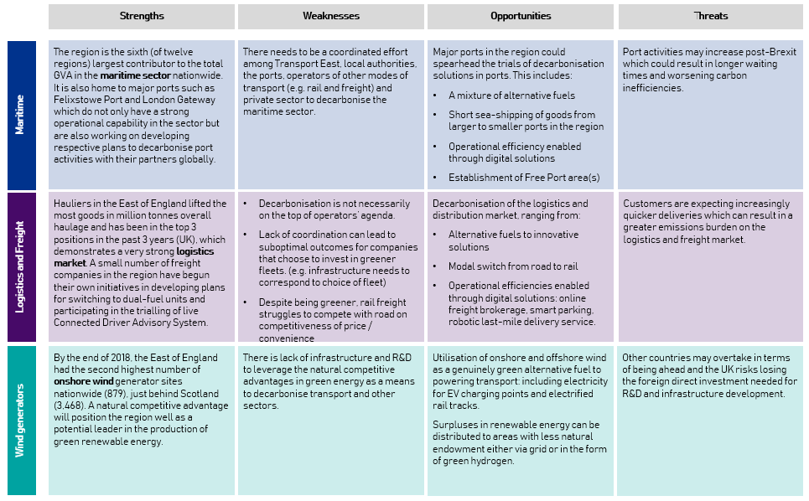

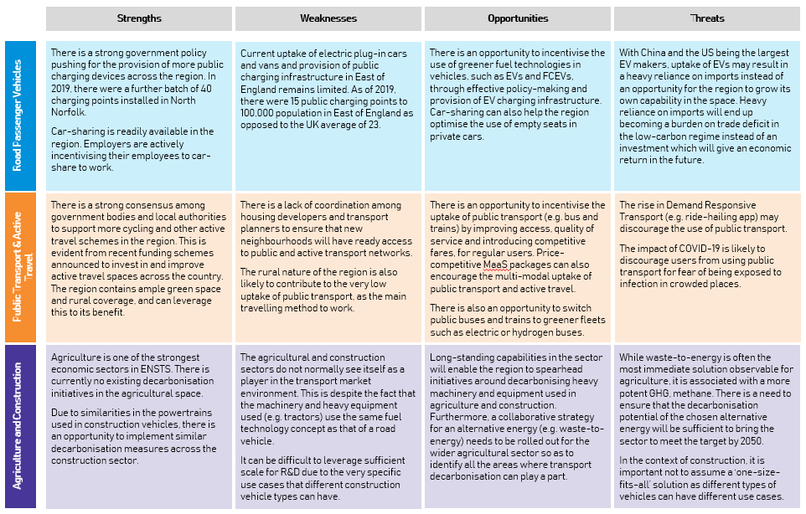

Indicative long list of regional decarbonisation opportunities

Based on extensive research and outputs from several rounds of stakeholder engagement with both public and private sector organisations across the region, representing a broad range of industries, an indicative long list of specific decarbonisation opportunities has been produced. This is continuing to be developed, refined and agreed with respective stakeholders.

The potential opportunities listed span across the six initial areas identified in the preceding sections of this report and aim to specifically indicate the types of stakeholders that may be best placed to lead on / deliver them. It is important to note that not all of the opportunities contained in this long-list will be relevant for, or directly attributable to the responsibilities of, Transport East / Local Government. However, they have been captured for the purposes of completeness and to provide stakeholders with a view of opportunities across the transport ecosystem. The next step will be to further refine and agree responsibilities for each opportunity and decide which ones to take forward and begin developing respective business cases or programmes of work for.

The following legend provides the explanations for the colours and markings attached to each of the opportunities in this long list in the following pages.

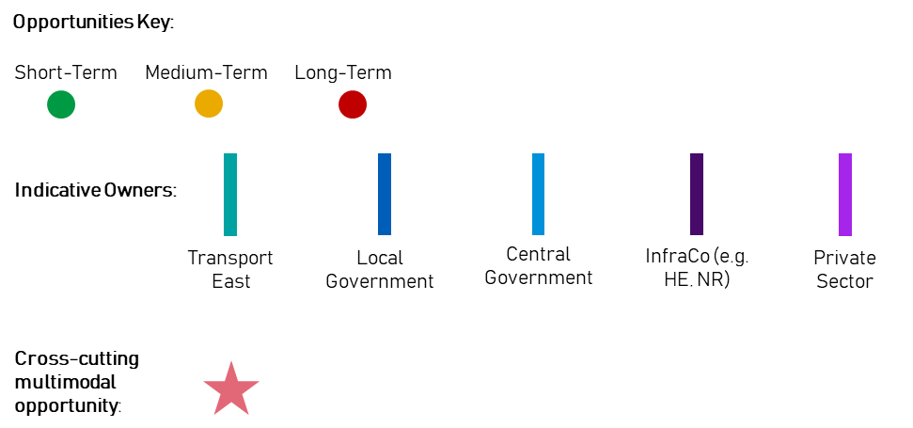

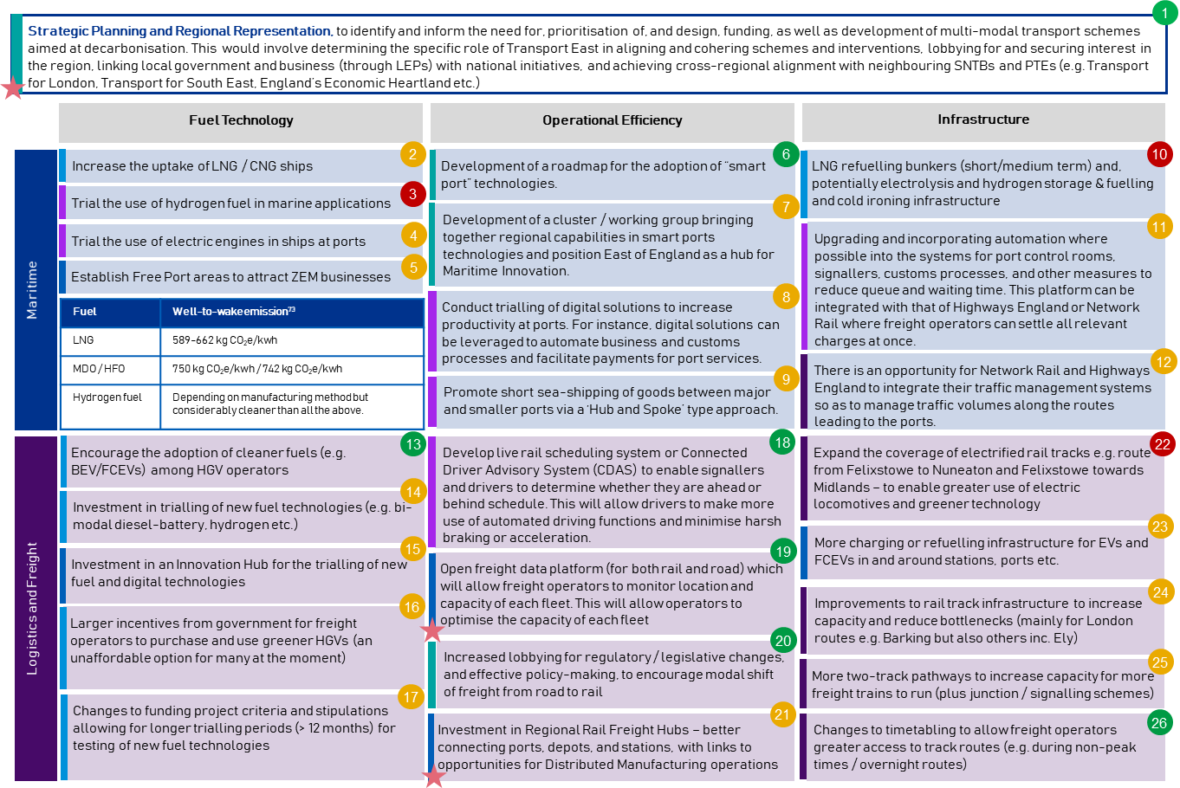
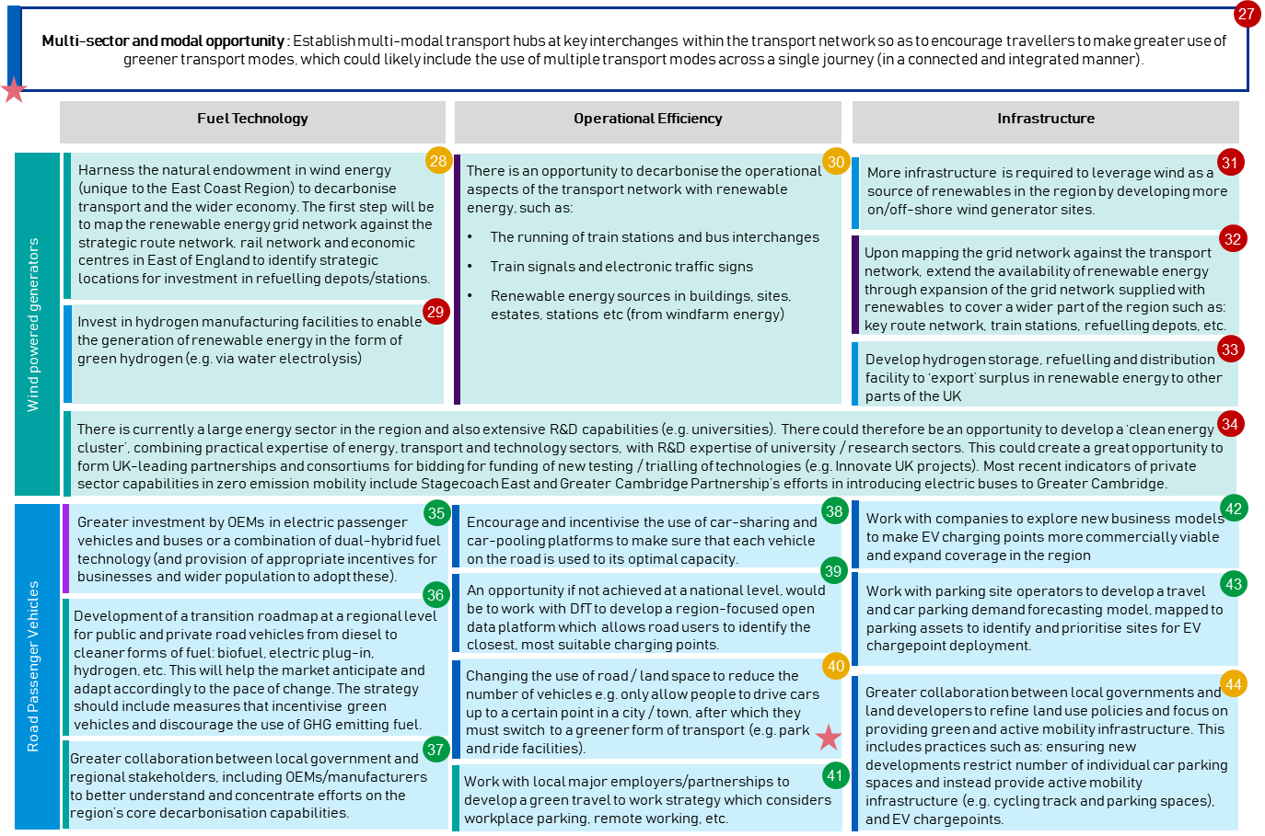

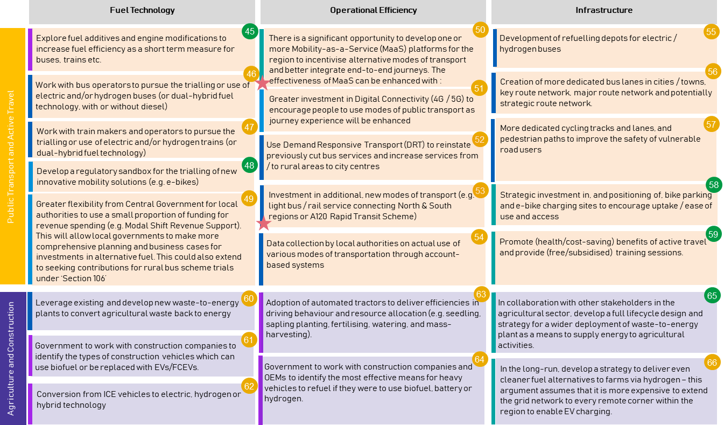

Transport East Proposed Strategic Actions and Interventions

The role of Transport East will be crucial in achieving a reduction in carbon emissions across the region’s transport network and ecosystem.

With this in mind, outlined below is a high-level mapping on the specific opportunities / actions / interventions which Transport East could lead and be directly responsible for, in the effort to achieve decarbonisation. The opportunities below have been selected from the long list of opportunities within Section 5 above.

These have been categorised against the following five ‘types’ of interventions, and mapped against a high-level timeline:

Figure 6.1: Transport East Strategic Actions & Interventions
Education & Skills
Infrastructure
Policy
Policy
Digital
Public / Private Sector Alignment
Current position
A cleaner and greener regional transport network and ecosystem
Development of a roadmap for the adoption of ‘smart port’ technologies
Development of a cluster / working group bringing together regional capabilities in smart port technologies and positioning the region as a hub for Maritime Innovation
Increase lobbying for regulatory / legislative changes, and effective policymaking, to encourage modal shift of freight from road to rail
Facilitate the mapping of the renewable energy network (wind energy) against the strategic road network, rail network and economic centres
Develop a ‘Clean Energy’ cluster, combining the energy, transport, technology and R&D capabilities in the region
Work with local employers to develop a ‘green travel to work’ strategy which considers car-pooling, workplace parking, remote working etc.
Develop a transition roadmap at a regional level, outlining the pathway for switching from diesel to cleaner forms of alternative fuels (e.g. biofuel, battery, hydrogen etc.)
Lead collaboration between Local Government and OEMs/manufacturers, to better help stakeholders understand and concentrate efforts on the region’s core decarbonisation capabilities
Develop programmes / portfolios for the deployment of one or more Mobility-as-a-Service (MaaS) and Integrated Ticketing platforms across the region
Strategic planning of, and investment in, region-wide infrastructure to encourage a modal shift to public transport and active travel (e.g. walking and cycling)
Run campaigns to promote (health/cost-saving) benefits of active travel and engage regional stakeholders to provide (free/subsidised) training sessions
Working with others, develop a full lifecycle design and strategy for a wider deployment of waste-to-energy plant as a means to supply energy for agricultural activities
Working with the agricultural sector, develop a long-term strategy to deliver even cleaner fuel alternative to farms via hydrogen
Short Term
(1 – 3 years)
Medium Term
(3 – 5 years)
Long Term
(> 5 years)
Campaign for changes to funding project criteria and stipulations, allowing for longer trialling periods (> 12 months) for testing of new fuel technologies
Work with Local Government to identify locations for investment in, and deployment of, more EV / FCEV charging and refuelling infrastructure
Assess the potential investment in an Innovation Hub for the trialling and testing of new fuels and technologies in the region
Working with Local Government, establish multi-modal transport hubs at key interchanges across the region’s transport network
6
7
15
17
20
23
28
34
36
37
41
50
27
65
66
58
59

Promote short sea-shipping of goods between major and smaller ports via a ‘Hub and Spoke’ type approach
Work with the construction sector to identify how alternative fuel technology can be applied to construction schemes
64
9

6.1 Key Immediate Actions by Transport East

The table below specifies the immediate actions that Transport East can take with respective to the opportunities listed in Figure 6.1 above:

Ref | Category | Name of Opportunity | Key Immediate Actions
59 | Education and Skills | Promote the benefits of active travel and provide relevant training sessions | Run campaigns to promote the benefits and incentives of active travel and engage regional stakeholders to provide training programmes at subsidised rates
58 | Infrastructure | Region-wide infrastructure development to encourage a modal shift from private vehicle use to public transport and active travel | Conduct a ‘demand assessment study’ into popular journey routes to identify places for investment in (e-) cycling infrastructure
36 |  | Develop a transition roadmap at a regional level, outlining the pathway for switching from diesel to cleaner forms of alternative fuels | Identify potential workable business models for green vehicles and infrastructure requirements to enable a complete switch from diesel by 2050
20 | Policy | Increase lobbying for regulatory / legislative changes, and effective policy-making, to encourage modal shift of freight from road to rail | Strengthen the level and frequency of engagement and communications with central government, to strengthen the East of England’s position as a leader in decarbonising transport
37 |  | Lead collaboration between Local Government and OEMs/manufacturers, to better help stakeholders understand and concentrate efforts on the region’s core decarbonisation capabilities | Identify potential Government funding sources and establish local consortia based in the East of England which can help the region demonstrate its capabilities in the decarbonisation of (road) transport
41 | Public/ Private Sector Alignment | Work with local employers to develop a ‘green travel to work’ strategy which considers car-pooling, workplace parking, remote working etc. | Identify the largest employers in the region and car-sharing providers, who can work with local authorities to come up with practical ride-sharing initiatives, taking into account the impacts of Covid-19, the government’s current / future guidance and the needs and preferences of employees
63 |  | Working with others, develop a full lifecycle design and strategy for a wider deployment of waste-to-energy plant as a means to supply energy for agricultural activities | Identify and make initial contact with regional stakeholders (e.g. waste management companies, energy companies, OEMs and R&D/academic institutions) in the waste-to-energy space
6 | Digital | Development of a roadmap for the adoption of ‘smart port’ technologies | Work together with ports to identify the challenges (e.g. business and customs processes) which can be addressed via digital solutions and begin considering improvements in digital connectivity to further accelerate this initiative
7 | Education and Skills | Development of a cluster / working group bringing together regional capabilities in smart port technologies and positioning the region as a hub for Maritime Innovation | Establish local consortia based in East of England which can help the region demonstrate its capabilities in “Maritime Innovation”
23 | Infrastructure | Work with Local Government to identify locations for investment in, and deployment of, more EV / FCEV charging and refuelling infrastructure | Conduct a forecast demand assessment for EV/FCEV and make a funding case to propose the trialling of the use of, and potential business models for, green vehicles/fuels
28 |  | Facilitate the mapping of the renewable energy network (wind energy) against the strategic road network, rail network and economic centres | Establish a working group among transport service operators, road authorities, Highways England, Network Rail and National Grid to address the future supply of renewable energy for transport in the region
17 | Policy | Campaign for changes to funding project criteria and stipulations, allowing for longer trialling periods (> 12 months) for testing of new fuel technologies | Collate the views of stakeholders in respect of current funding programme challenges and communicate these to central government with recommendations on potential solutions
64 | Public / Private Sector Alignment | Working with the agricultural sector, develop a long-term strategy to deliver even cleaner fuel alternative to farms via hydrogen – for use in everyday operations | Identify and begin initial communications with relevant stakeholders in the agricultural sector to address the decarbonisation challenge in the use of heavy agricultural machinery and equipment
9 |  | Promote short sea-shipping of goods between major and smaller ports via a ‘Hub and Spoke’ type approach, as opposed to transporting all goods from major ports via road and rail. The Port of London Authority are already leading similar initiatives by utilising short shipping routes along the Thames route. | Work with shipping companies and ports to identify the commercial viability of providing such services as well as incentives for logistics companies to opt for short sea-shipping services.
64 |  | Work with the construction sector to identify how alternative fuel technology can be applied to construction schemes | Work with construction companies and OEMs to identify the most effective means for heavy vehicles to refuel if they were to use biofuel, battery or hydrogen.
15 | Digital | Assess the potential investment in an Innovation Hub for the trialling and testing of new fuels and technologies in the region | Engaged with stakeholders across the Innovation and R&D sectors in the region (including universities) to assess the case for investment in an Innovation Hub
50 |  | Develop programmes / portfolios for the deployment of one or more Mobility-as-a-Service (MaaS) platforms and Integrated Ticketing across the region | Identify existing initiatives relevant to MaaS and Integrated Ticketing and begin planning on how these can be developed further into actual, deliverable programmes
34 | Education and Skills | Develop a ‘Clean Energy’ cluster, combining the energy, transport, technology and R&D capabilities in the region | Build on opportunities #36, #6, #7 and #14 as pre-requisites to this – a well-developed regional capability is required to develop a ‘Clean Energy’ cluster that is capable of conducting an end-to-end carbon footprint assessment for new development projects
27 | Infrastructure, Policy, Public/ Private Sector Alignment, Digital | Working with Local Government, establish multi-modal transport hubs at key interchanges across the region’s transport network | Identify “pain points” in the regional transport network which will benefit from a multi-modal transport hub, using existing research and data e.g. Transport Evidence Base  When assessing “pain points” and potential locations, work with local/regional/national government to better understand consumer behaviour, needs and demands to best inform planning and investment decisions  Further, perform this assessment with a ‘spatial’ perspective in mind, considering development of hubs in locations which can reduce the need for travel

Conclusion and Next Steps

This Decarbonisation Evidence Base and Strategic Recommendations Report has:

- Set out the regional context (including the current ‘as-is’ position and example ongoing initiatives);
- Outlined the key strategic areas / opportunities for achieving decarbonisation; and
- Identified a list of potential opportunities / initiatives to undertake across the transport ecosystem in the region.

With the support of regional stakeholders, Transport East will:

- Build on the work conducted to date and included within this report, to further refine and develop some of the strategic interventions identified
- Begin mobilising some of the interventions identified over the coming months and develop specific portfolios of programmes (and associated business cases if required)
- Use the outputs of this report to inform the development of Transport East’s wider Transport Strategy and activities to be undertaken across the transport network as a whole; and
- Ensure that any future transport activities and initiatives undertaken are performed with a parallel objective of reducing carbon emissions, to the extent possible.

The opportunities set out in this report are aligned with the UK Government’s target of Net Zero by 2050. The recommendations and opportunities identified will therefore be updated as necessary, should targets change, in order to remain aligned with the latest decarbonisation developments.

Appendices

Appendix 1 – Freight Carbon Emissions of Rail vs Ship vs Road

The total tonne kilometres of goods moved in the UK (2017): 147 billion tonne kms⁷⁰
The share of tonne kilometres by mode in 2017: Road (78%), Water (13%), Rail (9%)⁷¹
Total emission by HGV+LDV: 40.005 MtCO₂e; Water: 6.44 MtCO₂e; Rail: 1.61 MtCO₂e⁷²
MtCO₂e / billion tonne km by road freight = $\frac{Total road emission by HGV+LDV}{Total tonne kilometres moved on road}= \frac{40.00}{78\%.147}$
= $0.3489 {MtCo2e}/{billion tonne km}$
MtCO₂e / billion tonne km by water = $\frac{Total emission by shipping}{Total tonne kilometres moved on ship}= \frac{6.44}{13\%.147}$
= $0.3370 {MtCo2e}/{billion tonne km}$
MtCO₂e / billion tonne km by rail = $\frac{Total emission by rail}{Total tonne kilometres moved on rail}= \frac{1.61}{9\%.147}$
= $0.1217 {MtCo2e}/{billion tonne km}$
Note: The calculations above does not take into account goods moved internationally but goods moved within the UK only via road, rail and ship.

Appendix 2 – Sources and References

No | Source
1 | International Energy Agency
2 | BEIS: Final UK greenhouse as emissions national statistics 1990-2018
3 | Decarbonising Transport – Setting the Challenge
4 | Low Carbon Vehicle Partnership: The Low Emission Van Guide
5 | CNBC: News Article
6 | Scania is part of Europe’s First Long Haul Electric Truck Trials
7 | DAF Trucks’ First Electric Lorry Delivered to Supermarket Chain
8 | GOV.UK: Major boost for bus services as PM outlines new vision for local transport
9 | H2 Aberdeen
10 | H2 Aberdeen
11 | BEIS: Final UK greenhouse as emissions national statistics 1990-2018
12 | TSGB0101: Passenger transport by mode from 1952
13 | National Infrastructure Committee, Better Deliver: The Challenge for Freight
14 | Maritime 2050: navigating the future
15 | BBC: Climate Change: Should you fly, drive, or take the train?
16 | TSGB0109: Usual method to travel to work by region of workplace
17 | UK Reuters: China spearhead USD 300bn global drive to electrify cars
18 | Decarbonisation Road-map: A Path To Net Zero - A plan to decarbonise UK aviation
19 | VEH0131: Licensed plug-in cars, LGVs and quadricycles by local authority: United Kingdom
20 | VEH0105: Licensed vehicles by body type and local authority: United Kingdom
21 | Electric vehicle charging device statistics
22 | The Guardian: Labour vows to electrify England’s entire bus fleet by 2030
23 | GOV.UK: Britain’s first all-electric bus town to pave the way for green communities of the future.
24 | RIA Electrification Cost Challenge Report
25 | Bombardier signs €100m deal to make UK’s first battery-powered trains
26 | InsideEVs: South Korea and Hyundai raised the bar for hydrogen fuel cell cars in 2019
27 | Full Cell & Hydrogen Energy Association: Japan Fuel Cell Development
28 | Fuel Cell & Hydrogen Energy Association: South Korea Fuel Cell Development
29 | China Daily: 2020 marks end of support for fuel cell cars
30 | H2 Aberdeen
31 | H2 Aberdeen
32 | TfL: Twenty British-built zero-emission hydrogen buses will arrive next year
33 | Hydrogen Roadmap Europe: A sustainable pathway for the European Energy Transition
34 | Decarbonising Transport – Setting the Challenge
35 | BBC: All abroad Britain’s first hydrogen train
36 | GOV.UK: Abellio announced to run East Midlands Railway franchise from August 2019
37 | Hydrogen Diesel Injection in a Marine Environment
38 | The Guardian: Never knowingly undersoiled – John Lewis trucks to run on cow manure
39 | CNG Fuels: Refuelling Stations
40 | Oxford Institute for Energy Studies: LNG Supply Chains and the Development of LNG as a Shipping Fuel in Northern Europe 2019
41 | Low Carbon Vehicle Partnership: The Low Emission Van Guide
42 | BEIS: UK local authority and regional carbon dioxide emissions national statistics: 2005-2018
43 | Climate Emergency UK
44 | Socio-economic profile for East of England
45 | BEIS: Final UK greenhouse as emissions national statistics 1990-2018
46 | New Anglia LEP Board Meeting 26th February 2020
47 | New-Anglia Local Industrial Strategy
48 | BEIS: Renewable electricity by local authority
49 | Road Freight Statistics (RFS0121): Goods lifted and goods moved by region and country of origin
50 | East Anglian Daily Times: Freight companies want improvements to rail lines from Felixstowe
51 | Interview with Felixstowe Port and DP World London Gateway
52 | Transport East Regional Evidence base
53 | New-Anglia Local Industrial Strategy
54 | Plug-in battery-powered trucks coming to a road near you soon
55 | Norwich could get 50 new buses if bid for transport cash millions succeeds
56 | The road to Zero
57 | BBC - Stansted Airport expansion rejected by Uttlesford council
58 | New emission-saving measures take off at Stansted Airport
59 | Network Rail - New Trimley bridge provides safer access across railway
60 | Vision for £500m light railway connecting 24 towns and villages is revealed
61 | Financial Times: UK trade deficit hits widest in eight years
62 | State of the Maritime Report 2019
63 | VEH0105: Licensed vehicles by body type and local authority: United Kingdom
64 | GOV.UK: Britain’s first all-electric bus town to pave the way for green communities of the future.
65 | TSGB0109: Usual method to travel to work by region of workplace
66 | RIA Electrification Cost Challenge Report
67 | VEH0131: Licensed plug-in cars, LGVs and quadricycles by local authority: United Kingdom
68 | VEH0105: Licensed vehicles by body type and local authority: United Kingdom
69 | DEFRA: Agricultural facts – commercial holdings at June 2018
70 | Domestic Road Freight Statistics, United Kingdom 2017
71 | NIC Report, Better Delivery: The Challenge for Freight
72 | 2018 UK greenhouse as emissions: final figures – statistical release
73 | Oxford Institute for Energy Studies: LNG Supply Chains and the Development of LNG as a Shipping Fuel in Northern Europe 2019

Appendix 3 – Stakeholders consulted

 | One-to-One Stakeholders |  | Roundtable Stakeholders
1 | SEMLEP / UK Innovation Corridor | 16 | Energy Hub
2 | Suffolk Chambers of Commerce | 17 | British Sugar
3 | Success Essex Board | 18 | New Anglia LEP
4 | Simarco International | 19 | Peel Ports
5 | Network Rail | 20 | Deutsche Bahn
6 | Network Rail (East Anglia) | 21 | First Group
7 | C2C | 22 | Port of London Authority
8 | East Midlands Trains | 23 | Highways England
9 | Stagecoach | 24 | Road Haulage Association
10 | Freightliner Group | 25 | Port of Tilbury London Limited
11 | Hutchinson Group / Port of Felixstowe |  | Workshop Stakeholders
12 | DP World | 26 | Transport East Officers & Members
13 | London Strategic Land | 27 | Local Councillors and representatives from Local Authorities
14 | Intu
15 | Liftshare

