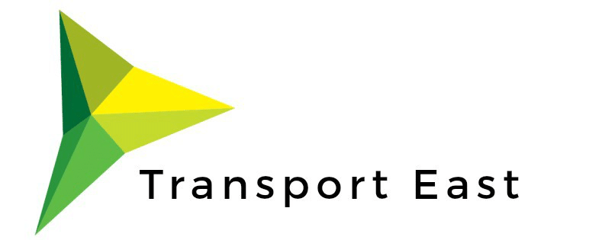

Cllr Kevin Bentley
Chairman, Transport East
By email
19 January 2021

Dear Alan Shaoul,
Re: Transport East support for the Thames Freeport
We are writing this letter to commend the proposed Thames Freeport. Following discussions with the Freeport partners, DP World and Forth Ports, we are confident their vision for the Thames Freeport delivers a unique opportunity for regeneration and the development of a cluster of innovative, sustainable industry.
Thames port is a valuable asset to the local, regional and national economy and a crucial global connection in UK trade. As we develop our transport strategy Transport East has identified ‘supporting global gateways’ as one of our three strategic outcomes. The Thames Freeport proposals are aligned with our ambitions to support a diverse and thriving eastern economy, level-up coastal communities and decarbonise transport across the region.

We are committed to working with DP World and Forth Ports to make sure the surface transport investment required to support a successful and sustainable Freeport is developed alongside the wider plans.
We are happy to be named in the Freeport bid as a supporting partner.
Yours Sincerely
